35.45: a) If the two sources are out of phase by one half-cycle, we must add an extra half a wavelength to the path difference equations Eq. (35.1) and Eq. (35.2).
This exactly changes one for the other, for 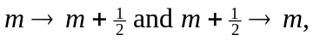 since in any integer.
b) If one source leads the other by a phase angle, the fraction of a cycle difference is 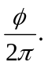 Thus the path length difference for the two sources must be adjusted for both destructive and constructive interference, by this amount. So for constructive inference: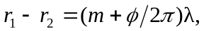 and for destructive interference, 